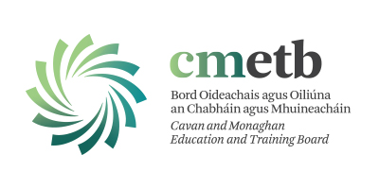

CMETB Community Education Service
Application for Grant Assistance 2022
(Community and Voluntary Groups)

APPLICATION FORM
GROUP INFORMATION

Group/Organisation name:

Where does the group meet?
Name of Contact Person/s:

Position in group/organisation:

Address of Contact Person:

Contact’s Telephone number:
Contact’s E-mail Address:
Main activities of the group:

Links with other agencies (if relevant):

Group tax or charity number (if relevant):
Number of employees/volunteers in group (if any):

FUNDING INFORMATION:

Have you ever received grant-aid from CMETB?

YES NO
If yes, please supply the following details:
Year Amount Course/Project:
Please detail how this money was spent?

For what purpose are you currently seeking a grant?

Name Of Course/ Project (if applicable):
Location of Course / Project (if applicable):
When will the course / Project be delivered (Start Date) if applicable:
Duration of Course / Project in weeks:
Duration of Course / Project in Hours:
Is the course accredited?
YES NO
Why is this funding needed and how did the group identify the need?

What target Group(s) will benefit from this funding?

Early School Leavers
Long Term Unemployed
Under employed / Sessional / Seasonal Workers
Low Skilled / Outside the workforce
Dependents of those unemployed
One Parent Families
Substance Misusers
People with a Disability
Ex-offenders
Travellers
Homeless
Older People
Migrants / Asylum Seekers/ Refugees
Disadvantaged Men/Women, particularly in rural isolation or RAPID area

Estimated number of individuals involved in your group:
Male Female
How will you evaluate the success of the funding?

Have you received additional funding from elsewhere for this purpose? If so, from who and for what amount?

Course/Programme Costing

Please give a breakdown of the costs below:
ITEM | COST (€)
Tutor/Facilitator Fee
Materials
Rent
Equipment
Other (please specify)
Total Cost

Please note: due to new departmental regulations grants will only be paid to groups once receipts and participant detail forms have been returned to the Community Education Facilitator. Essentially this means that grants will be paid on completion of course.

Signed: _____________________________________
(on behalf of Group)
Position: _____________________ Date: _______________
Please attach group accounts (where applicable) and return form to:
Monaghan groups- Carol Kelly, Community Education Facilitator,
CMETB, Dún Mhuire, Mullaghmonaghan, Monaghan, H18 T383
Or
Cavan Groups- Angela Kelly, Community Education Facilitator,
CMETB, Unit 5, Church View, Cavan H12 R82
By Friday 3rd June 2022
NO LATE APPLICATIONS WILL BE ACCEPTED

