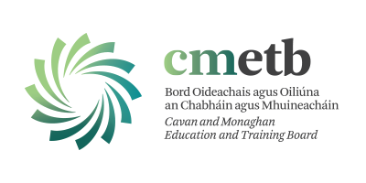 | Evening Provision  Cavan and Monaghan

Evening Provision Expression of Interest Form
- PERSONAL DETAILS
Personal Data on this Form – The information provided by you on this form will be retained and used by Cavan and Monaghan ETB. For further information on what data we collect, why we collect it, how we use it and the legal basis for same, please go to our Data Privacy Notice available at http://cavanmonaghan.etb.ie/data-protection/
First name:

Surname:

Address:

Email:
Contact number:
Emergency contact name & phone number:
Date of Birth:  Age (if under 23) | __/__/__  ___ years | PPS number:
Do you come from outside the European Economic Area (EEA) | Yes ___  No ___ | If you answered yes, do you hold a GNIB card with a stamp 4, 5 or 6? | Yes ___  Expiry Date: __________  No____

- COURSE DETAIL

Indicate the title of the course you wish to apply for, the level and which county you want to do the course
Course Title & Level:
Cavan or Monaghan:
Other courses/subjects of interest) | (Please list any other courses/subjects you would be interested in completing or attending)

- EMPLOYMENT DETAILS (Current or most recent)

Are you currently employed?
If yes, what is your job title?

- RELEVANCE OF COURSE FOR YOUR CURRENT OR FUTURE EMPLOYMENT

How is the course relevant to your current job/future employment?

- EDUCATON
Participants must be at least 16 years of age by the date on which the course starts. They must also have completed one of the following programmes: Leaving Certificate; Leaving Certificate Vocational Programme (LCVP); Leaving Certificate Applied (LCA); QQI Level 4 major award or equivalent.
Applications will be considered from those aged over 23 who do not have one of the above qualifications but who can demonstrate their capacity to study at Level 5 or Level

Indicate your highest level of academic achievement: (For example: junior cert / leaving cert / honours degree in history etc.)

- DO YOU NEED SUPPORT?

Do you require any additional supports when attending the course? | No Yes, please list below  (Your course provider will make every reasonable effort to put supports in place for you, but they might not be able to put all of the supports in place for practical and other reasons)
If you have answered yes, please inform us of any support you have previously received in education/employment
Do you require support for any of the following | English Language  Numeracy  Literacy (reading/writing/spelling)  Digital Literacy (computers)  Other ____________________________________________________

How did you hear about our Evening Provision Courses?
Social Media Work CMETB Website Road Sign
Word of Mouth Radio Fetch.ie College Open day
Friend / Family Advert Other
Please advise _________________
Please be aware that courses will commence when there are sufficient learners enrolled on the course. The start date and further details will be confirmed to you by the Evening Provision Team by email in advance of the course starting.
If you have any queries, please contact the Evening Provision team eveningcourses@cmetb.ie

